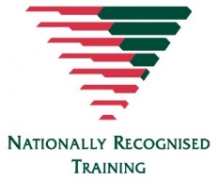AHC31016 – CERTIFICATE III
Parks and Gardens
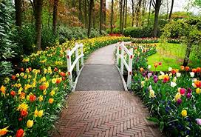

Open to anyone over the age 16 years.

If interested, complete an Expression of interest form. (Classes to be held in Goodna)

Delivery Method
Blended - this course will be delivered over 8 - 10 weeks and consists of face to face classroom/ outdoor practical learning 2 days a week, and self-directed learning task.

Course Overview
The qualification applies to specialist occupations in Parks and gardens, Landscaping and Horticulture with
participants able to work in their chosen place of employment as a landscaper, gardener, or groundskeeper.

Fees and Funding
$20 Admin Fee Applies
Certificate 3 Guarantee Program – this qualification can be delivered under the Certificate 3 Guarantee to students who meet eligibility criteria.

Not open to students enrolled in school as this is considered full-time study.

Work boots, hat and a water bottle required.
